**Danube Hospital**

Directed by Nikolaus Geyrhalter; Austria | 2012 |75 min.

February 22nd, 6:30pm at McConomy Auditorium, Carnegie Mellon University

Presented in conjunction with the Imperfect Health Exhibition at [Miller Gallery](millergallery.cfa.cmu.edu).

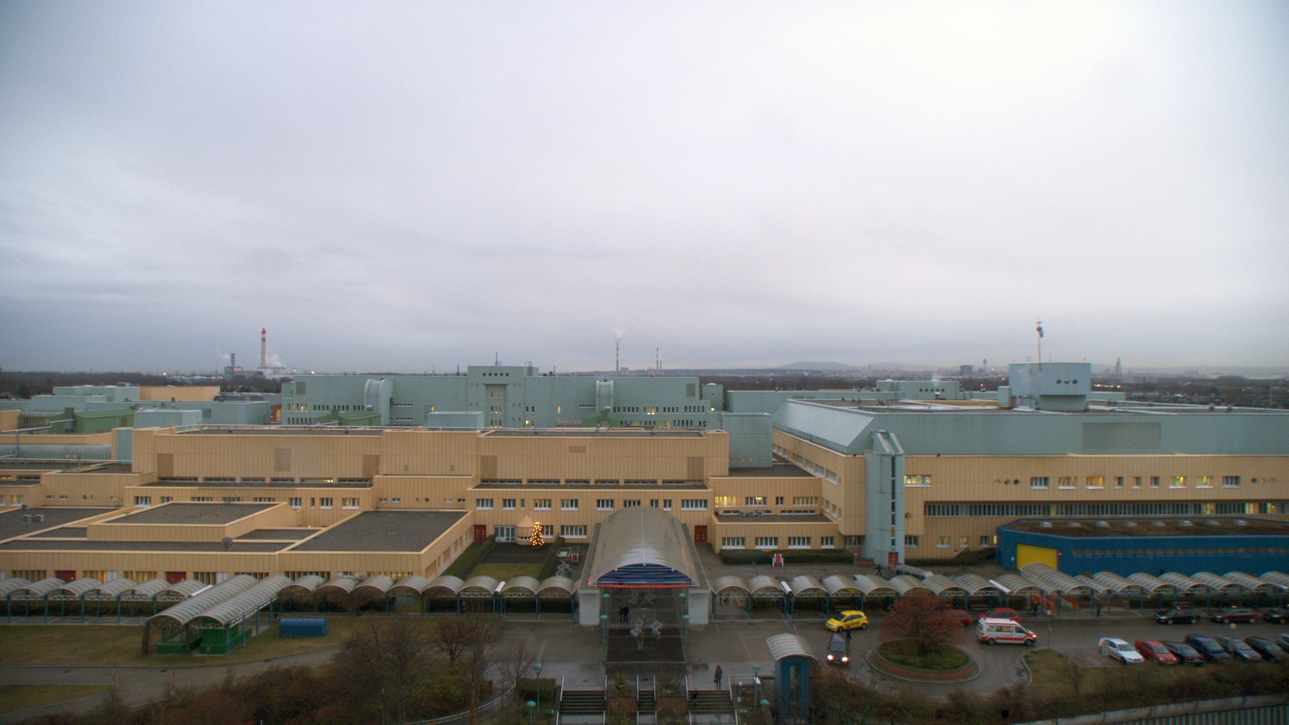

**Pittsburgh Premiere**

“Geyrhalter’s tripod-mounted, impeccably-framed images capture the interactions of human and machine that have come to define the hospital experience in the 21st century”

- *The Hollywood Reporter*

**Awards**

*Nominated for 2012 East Silver Caravan (Prague) Silver Eye Award

In *Danube Hospital*, sci-fi and avant-garde meet modern medicine. The setting is Austria’s Donauspital, where birth, death, and gore constitute day-to-day activity. Geyrhalter’s exquisite shot-compositions aestheticize each unit of the hospital microcosm. One might forget that what they are seeing is documentary footage—imagery of robot-like transporters and state-of-the-art computer technology echo futuristic, science fiction films of the past century (think *2001: A Space Odyssey,* but the spaceship is actually a hospital). Scenes of meat-cutting in the cafeteria and in the cadaver-dissection room evoke the same horror. No unit is granted too much camera time; each is interdependent on the rest, and functions as an integral combination of human and machine. Media screens play a significant role—it is, after all, through television monitors that we view the stitching of internal organs and an eye surgery. Media is not merely a commercial entity or art form—*Danube Hospital* illustrates its scientific function, its penetration into multiple realms of the contemporary, digitized era.

*Danube Hospital* will be preceded by a showing of Dr. Paul Goodman’s *Nurse.* As part of the Goodman Faces of Work series, the short film examines the daily work-life of one of the health industry’s most essential components.

Healthy refreshments provided by Hofbräuhaus prior to the screening.

**About the Director**

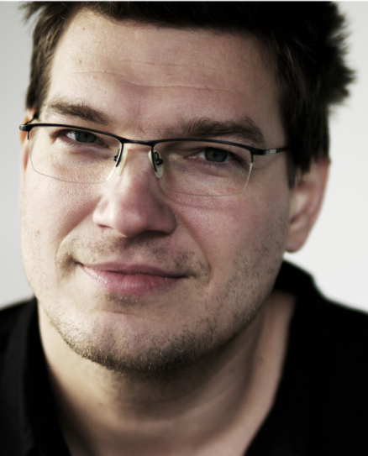

Nikolaus Geyrhalter was born in Vienna, Austria in 1972. In 1994, he founded his own production company titled Nikolaus Geyrhalter Filmproduktion (NGF). His award-winning works include *Das Jahr nach Dayton* (1997), *Pripyat* (1999), *Elsewhere* (2001), and *Our Daily Bread* (2005).

Purchase Tickets [here](cmu.edu/faces#tickets).